DAY-5

1) Create a launch template with a custom AMI and t2.micro instance type

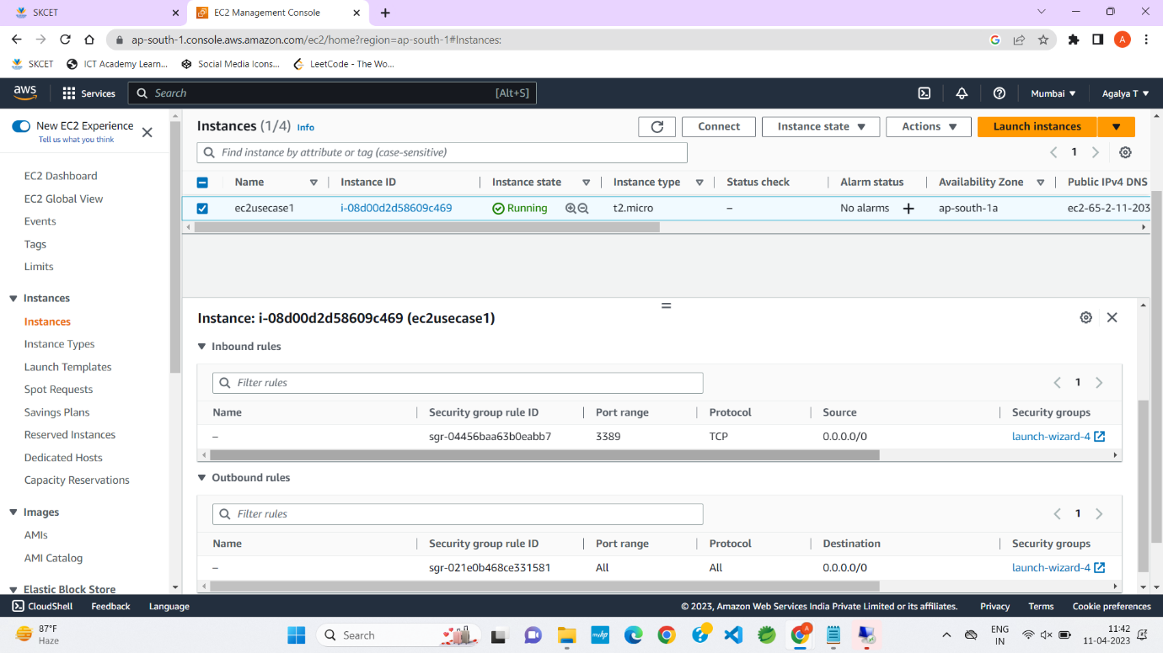

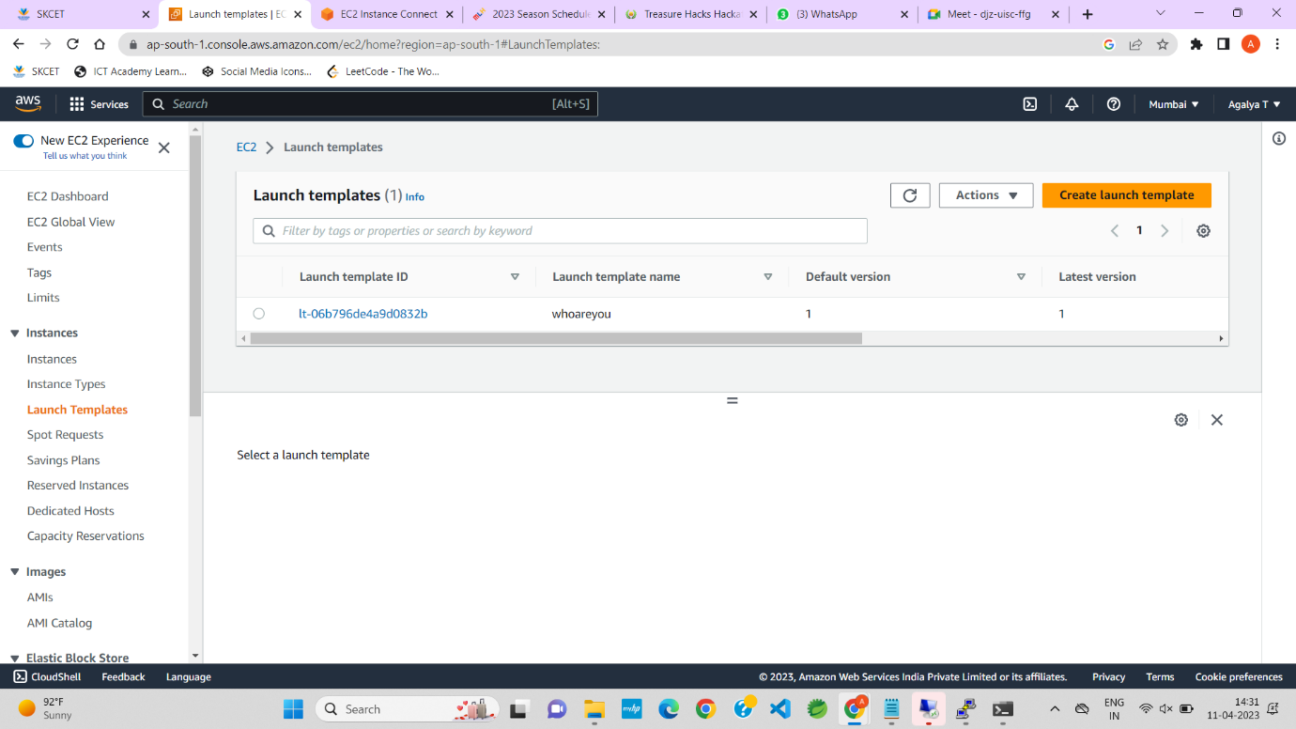

2) Create an autoscaling group with the above-created launch template

